**Company Code Configuration**

Contents

Transport Requests 2

Company Codes to be created (Copy from and Assignments) 2

Configuration Activities 4

Create Company 4

Copy, delete, check company code 4

Set Country-Specific Checks 4

Enter Global Parameters 5

Assign Company Code to Controlling Area 6

T001 Table view after customization 6

Leading Ledger (0L) for new company codes 6

Non-Leading Ledger (Z1) extended to new company codes 7

Ledger from which CO reads actual data (CoCds copied from country templates added) 8

Make sure items are added in the transport request 8

Define Tolerance Groups for Employees 9

Validation and Substitution in accounting documents 11

Define Currency Translation Ratios 12

Maintain Cost Centers 13

Steps carried out in DE1/140 14

SCC1 – Transport Requests imported 14

FS15: GL accounts copy (IN QE Copy GL Accounts and number ranges from 2300) 14

OBH1: Copy document number ranges 14

DE2140 Test Transactions 14

FB01 14

FB01L 16

Screen shot of F-01 17

# Transport Requests

|  |  |  |
| --- | --- | --- |
|  | Sequence |  |
| DE2K901685 | 1 | W1_RTR_FI_WF143091_new company code configuration example |

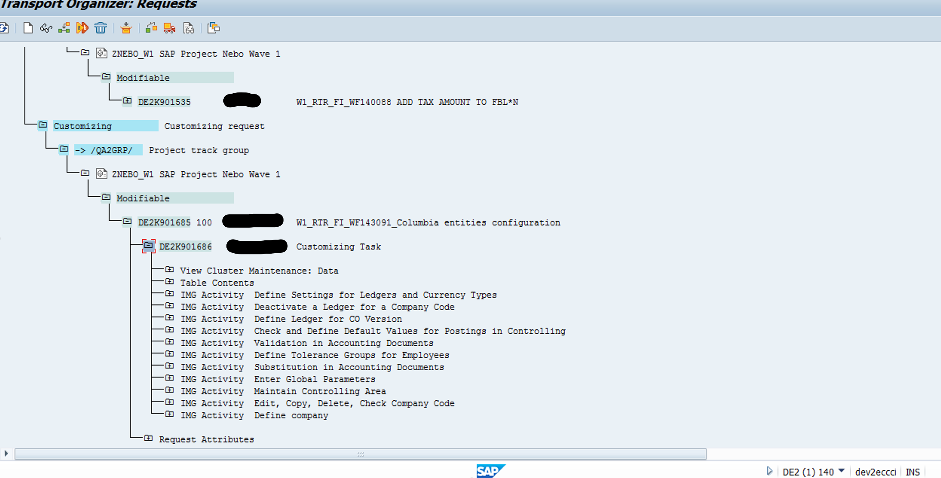

# Company Codes to be created (Copy from and Assignments)

|  |  |  |  |  |  |  |  |  |  |  |  |  |  |  |  |
| --- | --- | --- | --- | --- | --- | --- | --- | --- | --- | --- | --- | --- | --- | --- | --- |
| Company code | Name | Country | Currency | Country Key | Copy From | COA | CO Area | PPV | Company | Fiscal YV | Ledger | Acc Prin | FSG | Max Exch Rate Deviation | Credit Control Area |
| 2600 | <CC Name> | CO | COP | CO | 1000 | DT00 | DT00* | Z001 | 2600 | K4 | Z1 | LOGP | 0010 | 10% | DT00 |
| 2650 | <CC Name> | CO | USD | CO | 1000 | DT00 | DT00* | Z001 | 2650 | K4 | Z1 | LOGP | 0010 | 10% | DT00 |

*Country CO = Colombia

*Currency key COP = Colombian Peso

* There will be leading ledger 0L with assignment to accounting principle GAAP.

* Non leading ledger Z1 with assignment to accounting principle LOGP

* Colombia will share posting period variant Z001 which is used for international entities

* Should Colombia have Calendar year (Jan-Dec) set up as fiscal year?

# Configuration Activities

## Create Company

| Company | Name | Screenshot |
| --- | --- | --- |
| 2600 | <CC Name> |  |
| 2650 | <CC Name> |  |

## Copy, delete, check company code

|  |  |  |
| --- | --- | --- |
| 2600 | <CC Name> |  |
| 2650 | <CC Name> |  |

## Set Country-Specific Checks

## Enter Global Parameters

| Company code | Name | Country | Currency | Country Key | Screenshot |
| --- | --- | --- | --- | --- | --- |
| 2600 | <CC Name> | CO | COP |  |  |
| 2650 | <CC Name> | US | USD |  |  |

## Assign Company Code to Controlling Area

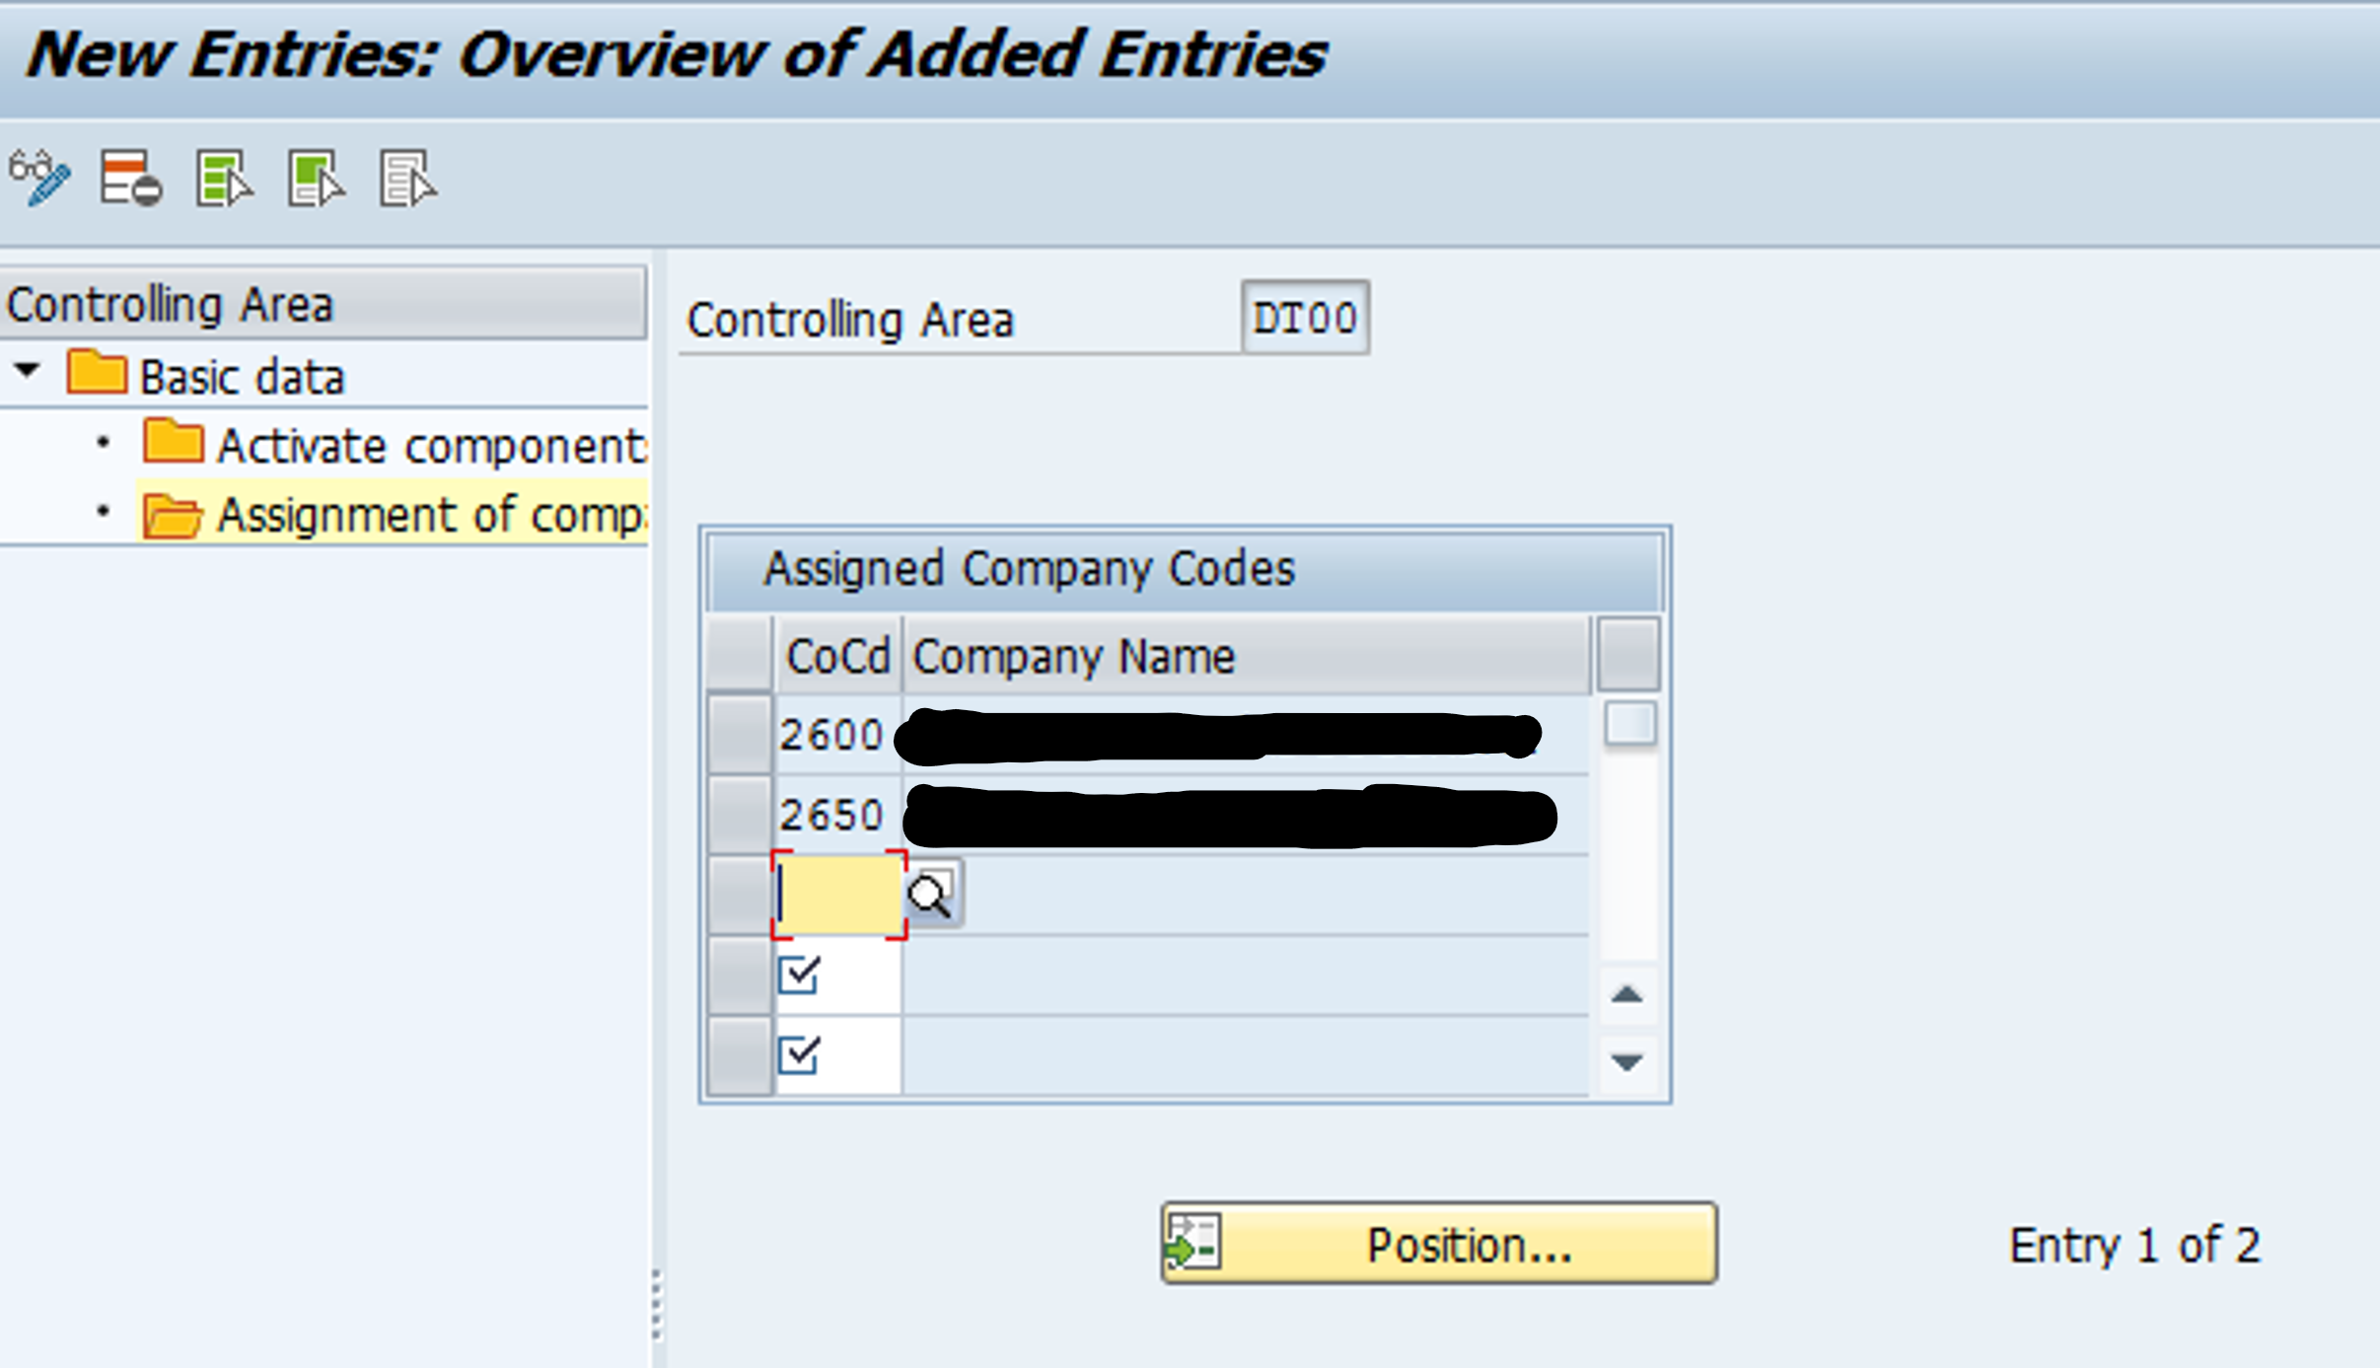

## T001 Table view after customization

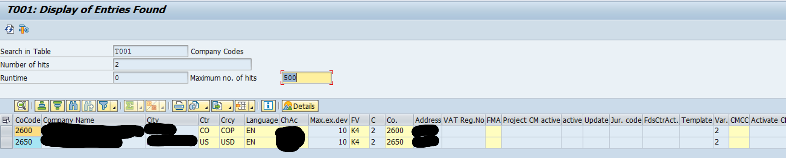

## Leading Ledger (0L) for new company codes

Newly created company codes (per this document) are automatically added to Leading Ledger 0L and assigned to accounting principle GAAP.

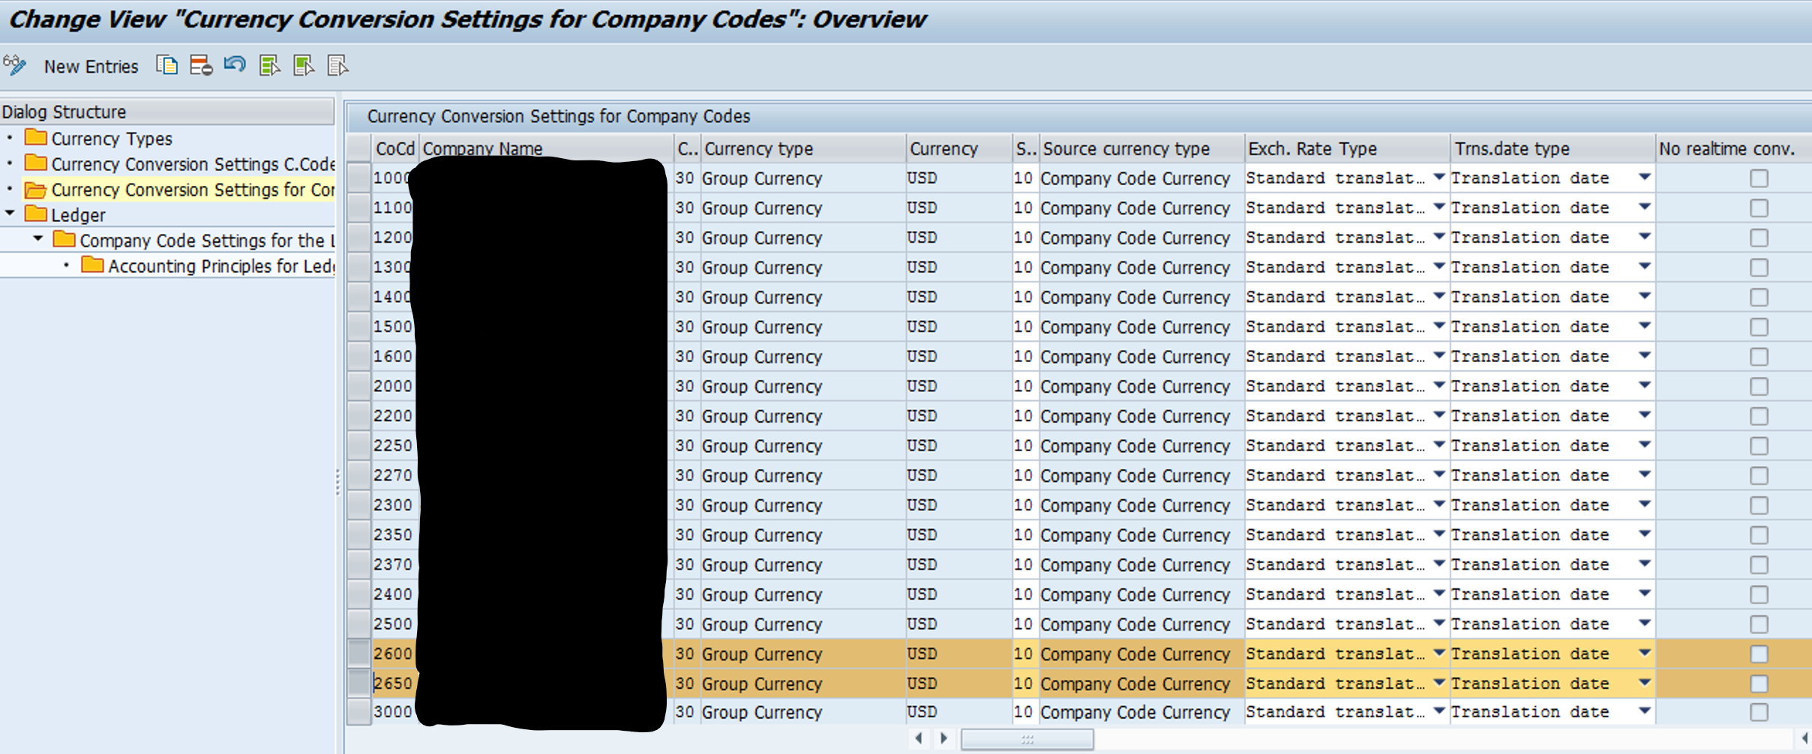

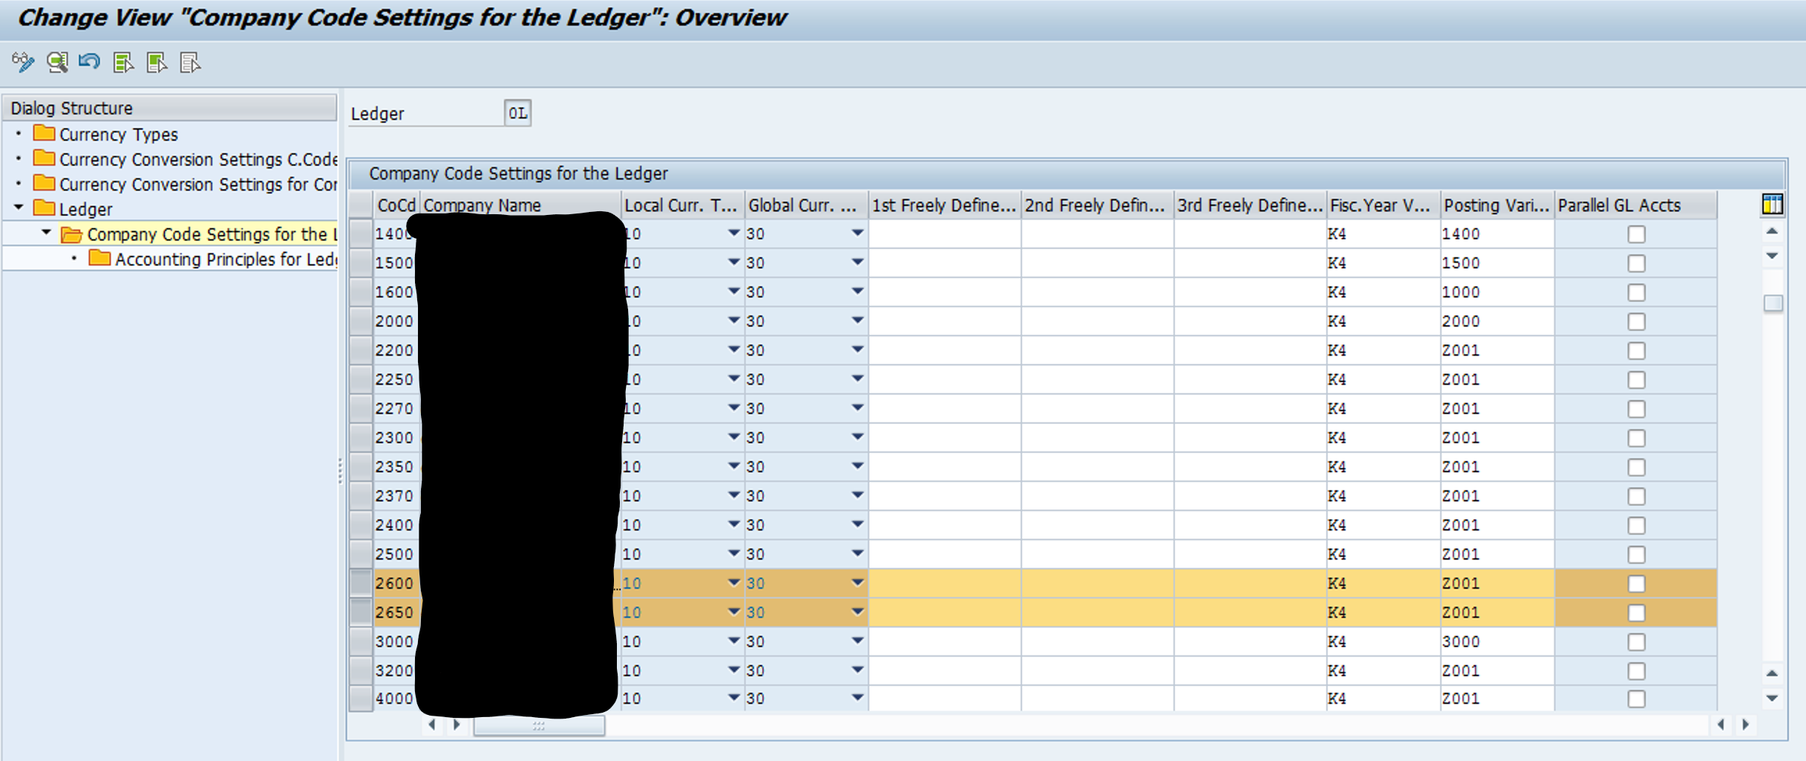

## Non-Leading Ledger (Z1) extended to new company codes

Company codes created by copying 1000 have been added to Non-Leading Ledger (Z1) by the copy program. Other company codes need to be created manually in this configuration activity.

| Company code | Name | Country | Currency | Country Key | Screenshot |
| --- | --- | --- | --- | --- | --- |
| 2600 | <CC Name> | CO | COP | CO |  |
| 2650 | <CC Name> | USA | USD | US |  |

## Ledger from which CO reads actual data (CoCds copied from country templates added)

Make sure items are added in the transport request. And double click on the company code make sure the Local currency and Global currency are there and safe it, so that it is added to the transport.

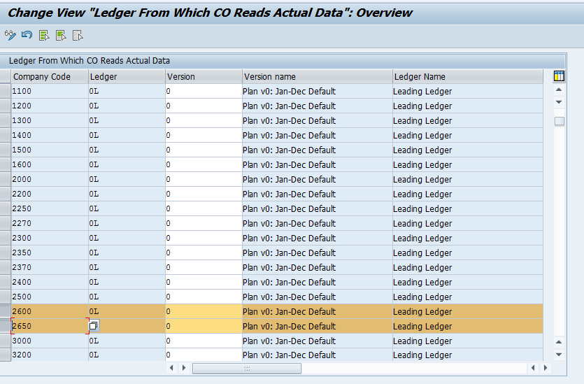

## Define Tolerance Groups for Employees

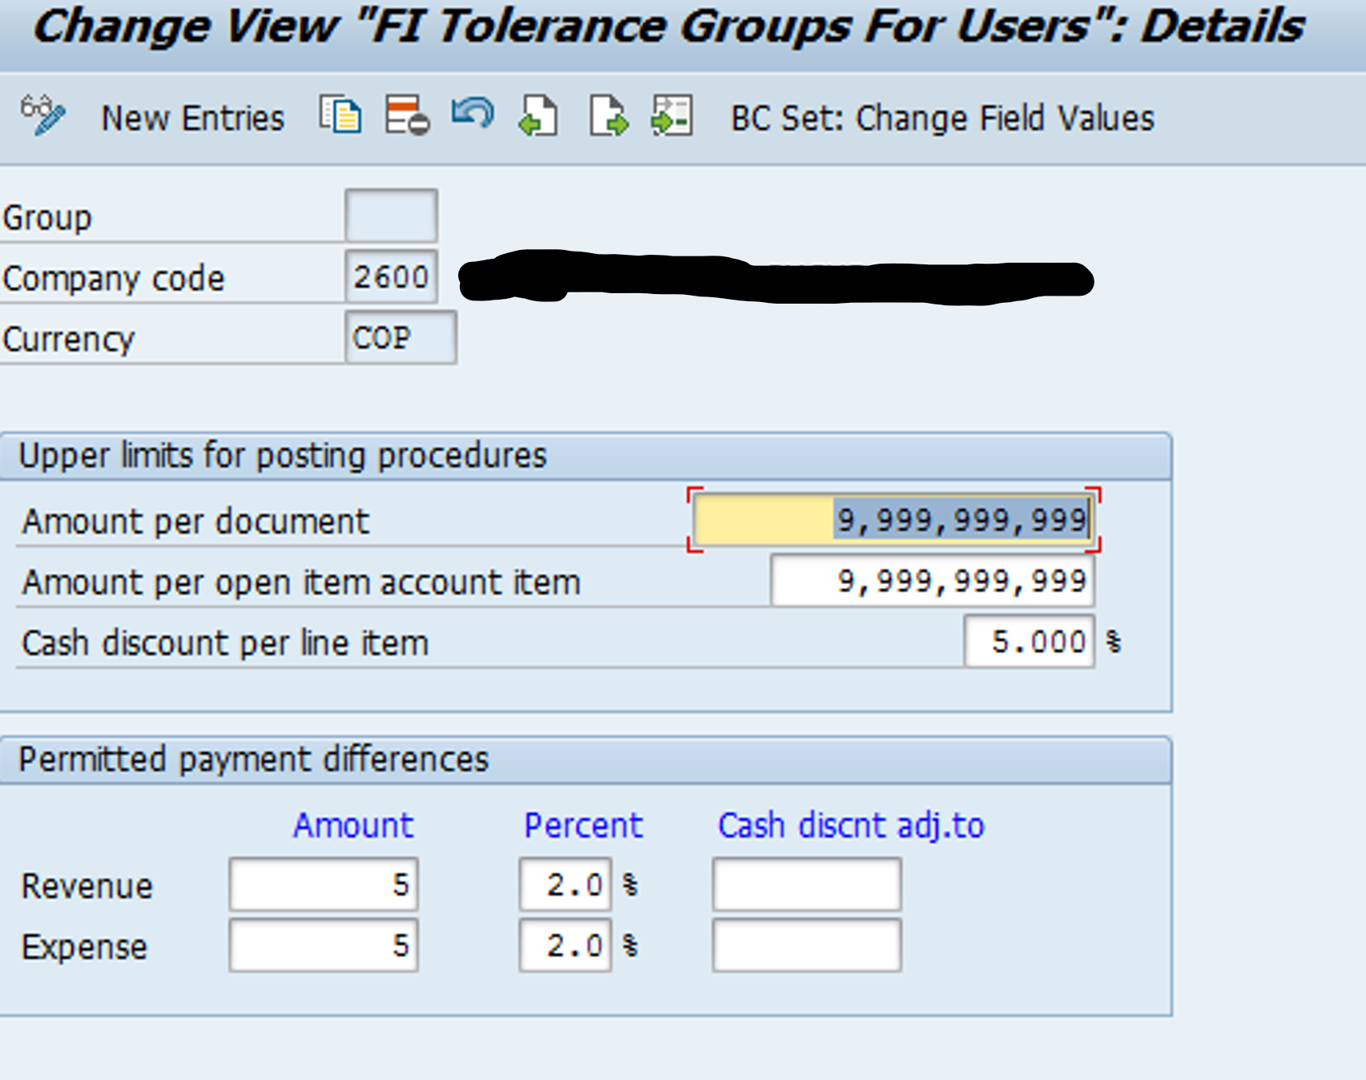

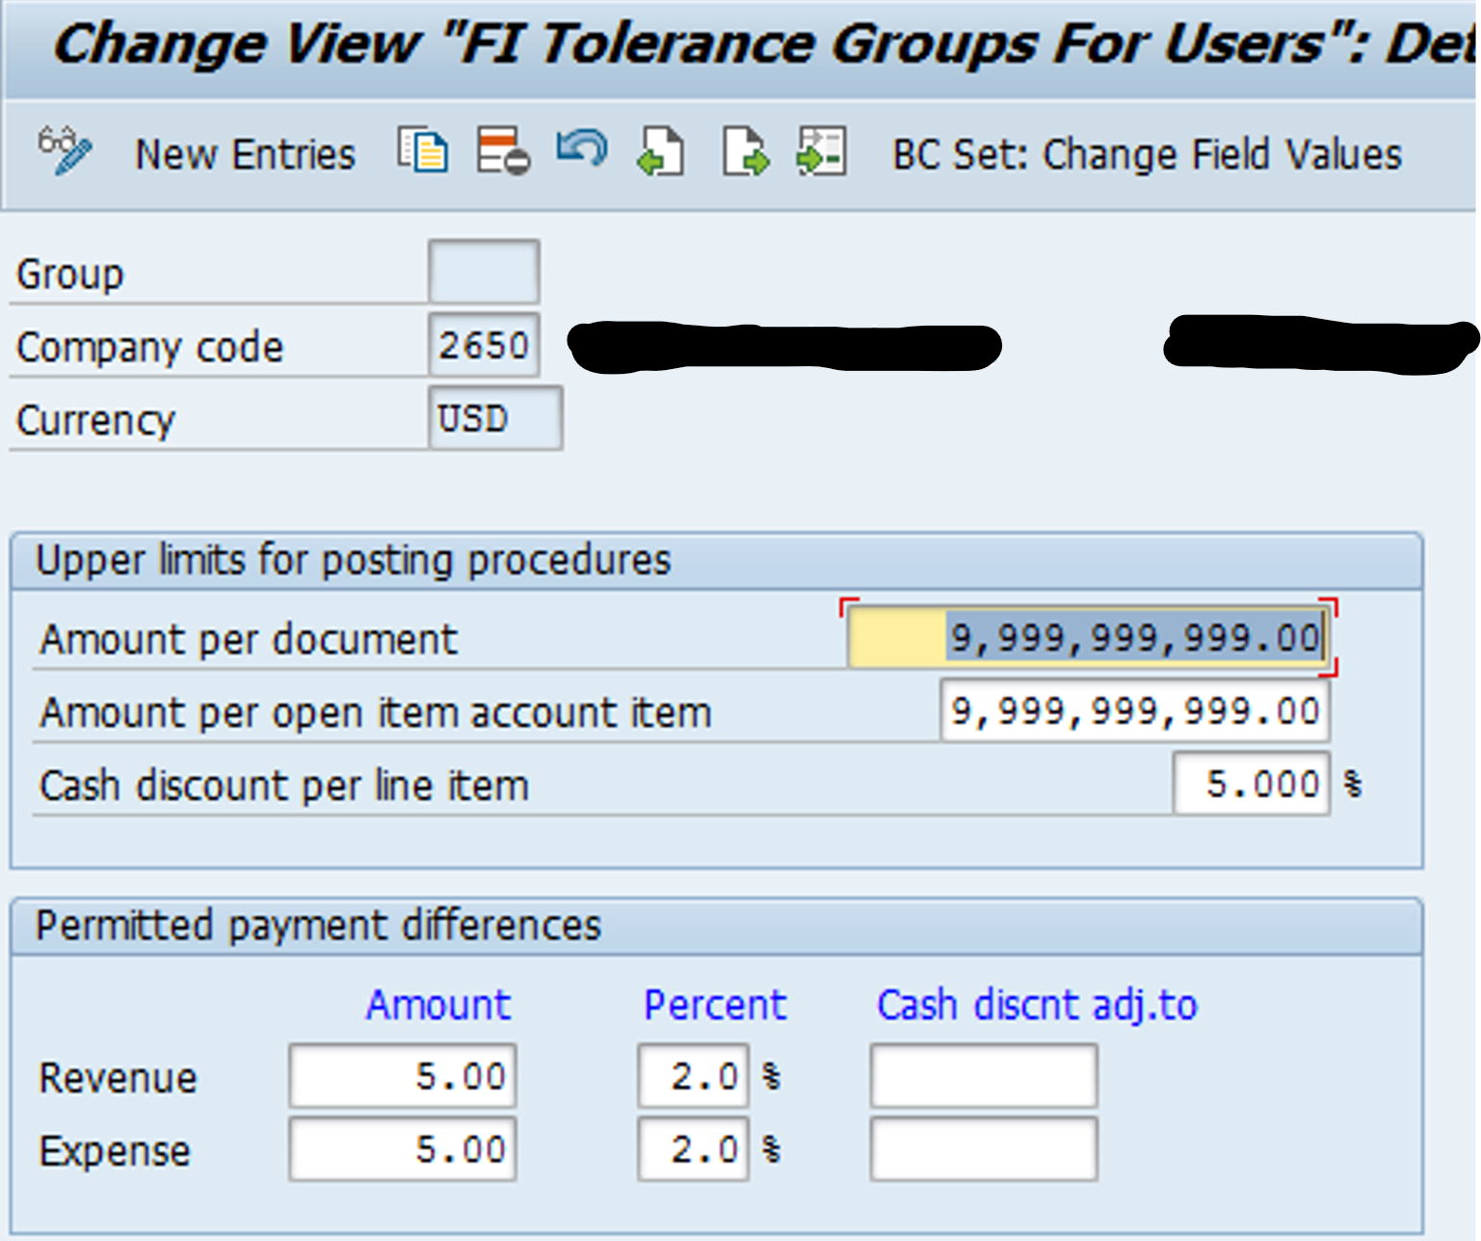

## Validation and Substitution in accounting documents

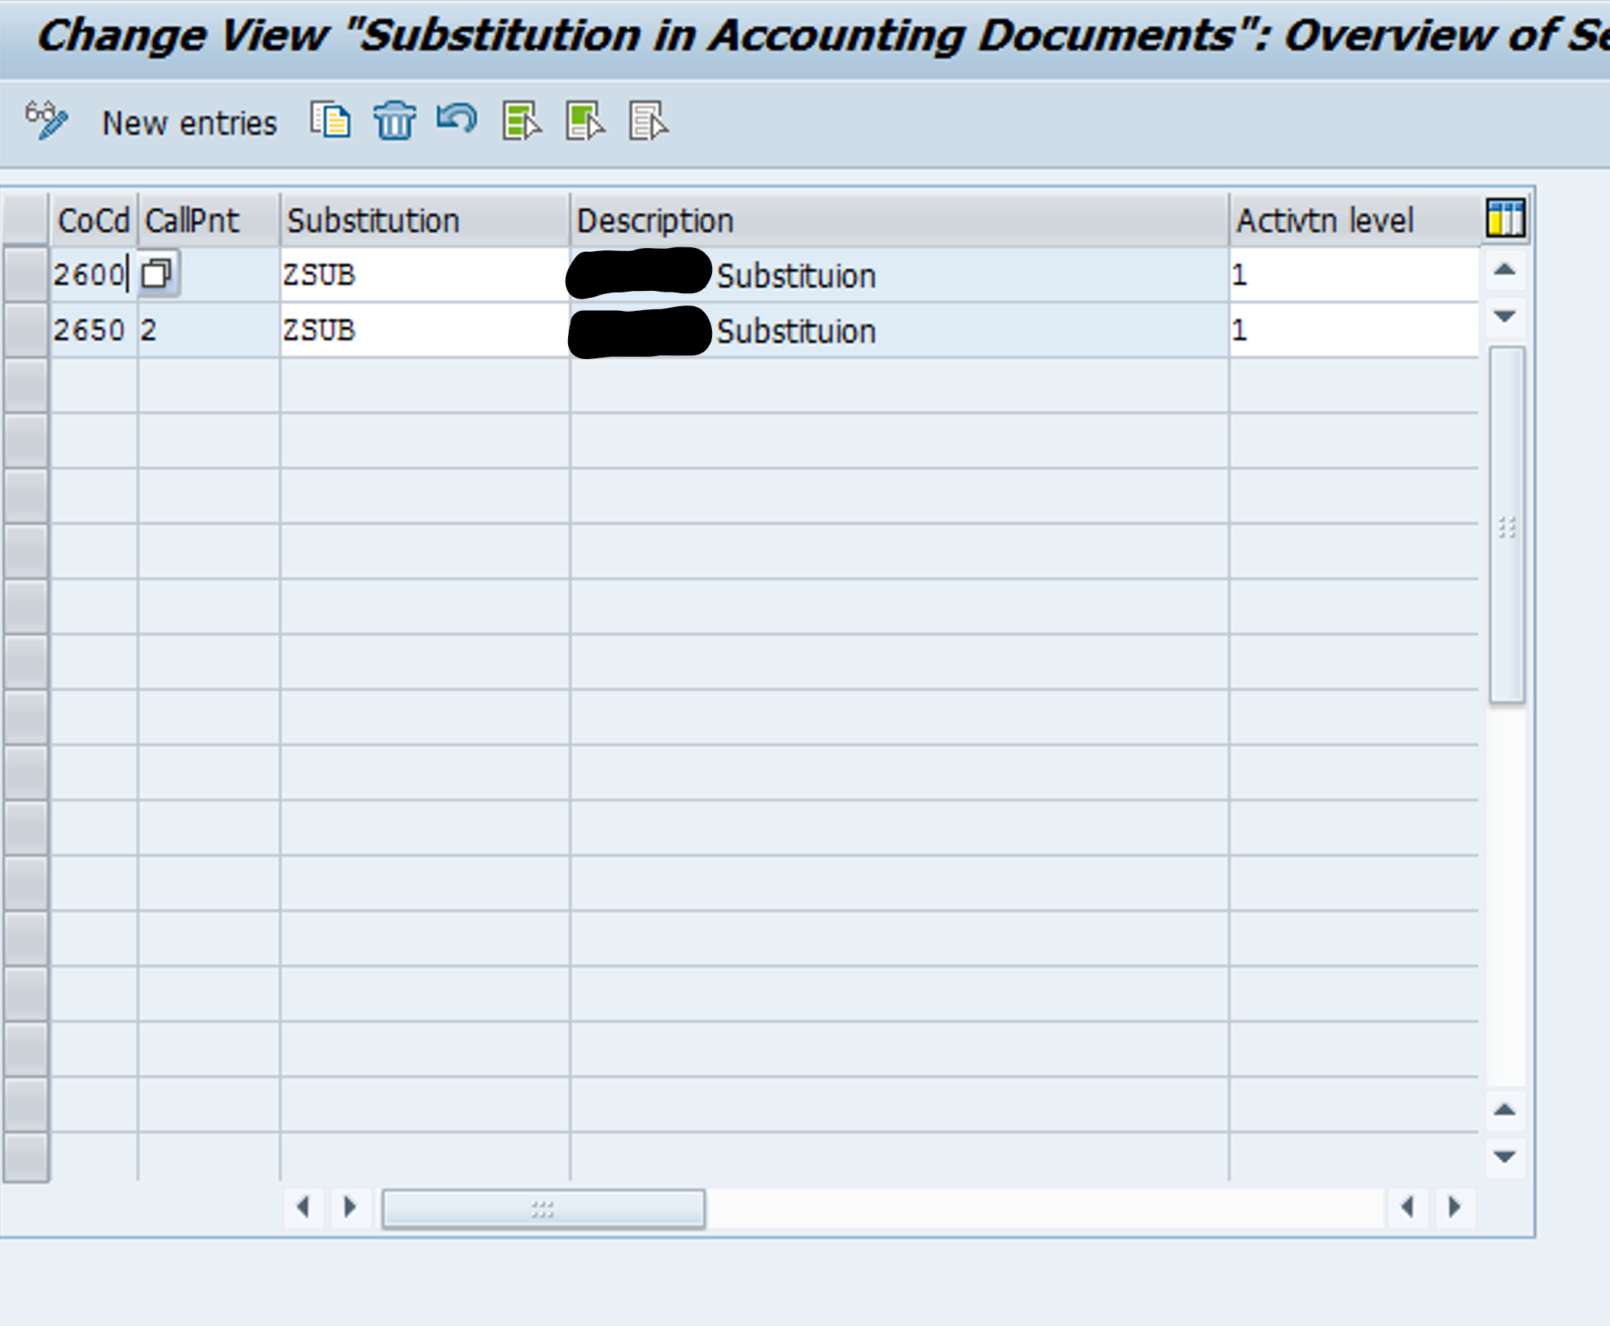

ZSUB_002_BUKRS_INCL

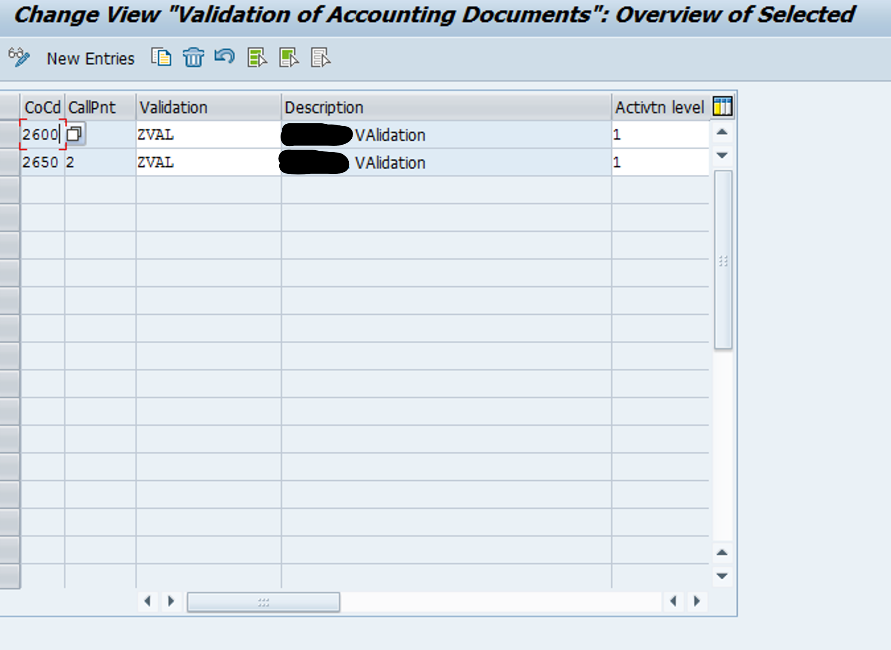

## Define Currency Translation Ratios

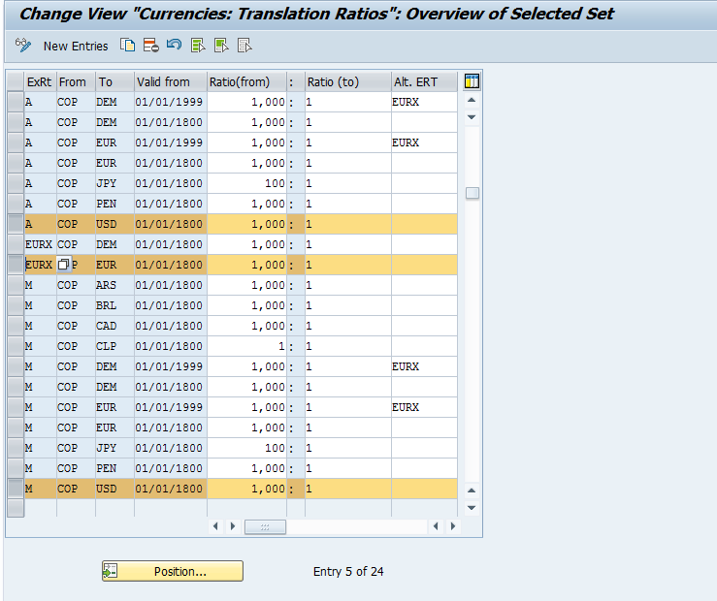

## Maintain Cost Centers

Cost centers should be maintained by client.

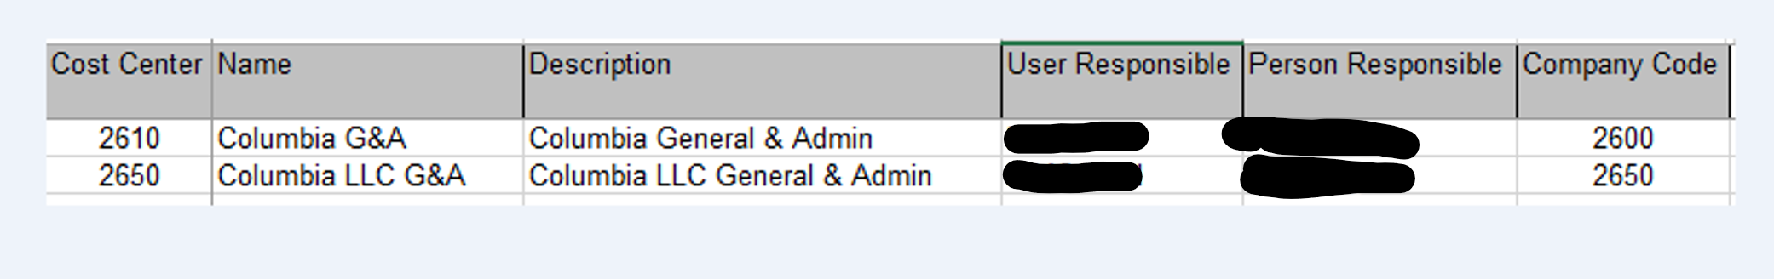

# Steps carried out in DE1/140

### SCC1 – Transport Requests imported

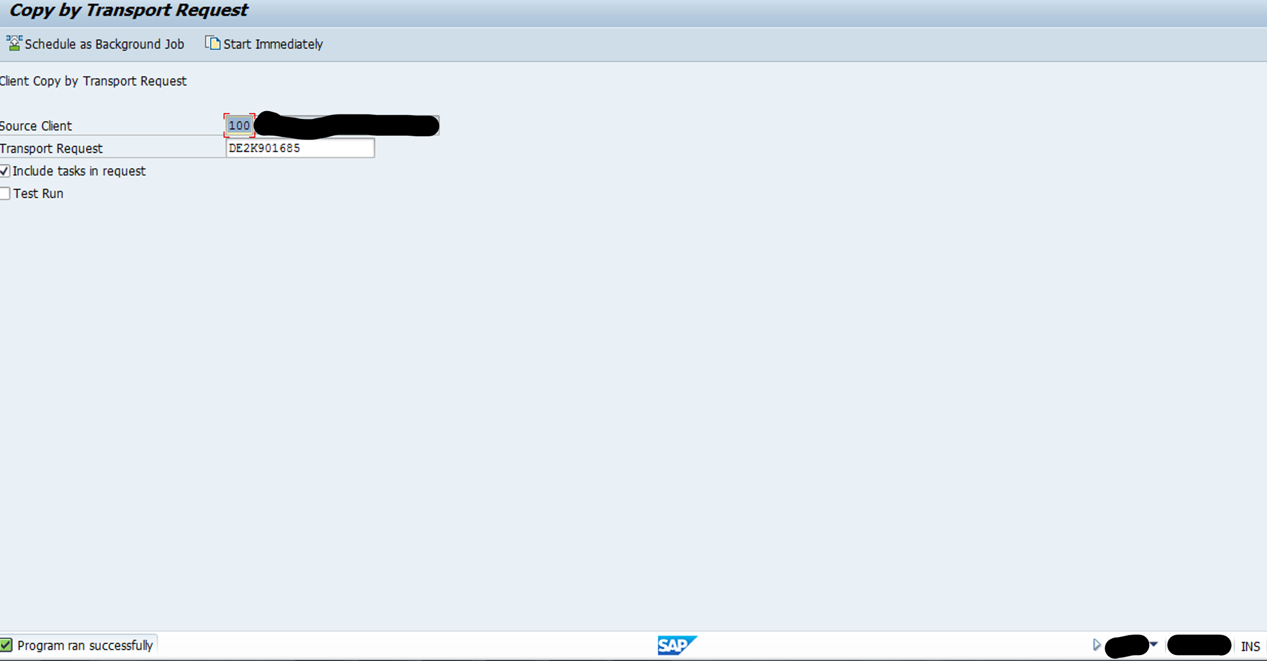

### FS15: GL accounts copy (IN QE Copy GL Accounts and number ranges from 2300)

### OBH1: Copy document number ranges

## DE2140 Test Transactions

### FB01

2600

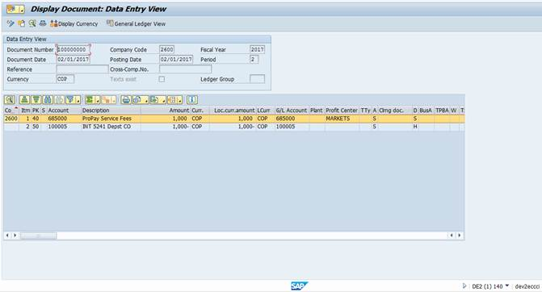

2650

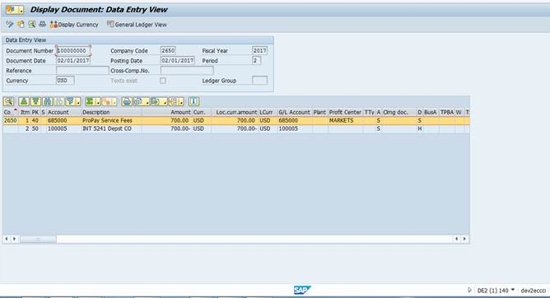

### FB01L

2600

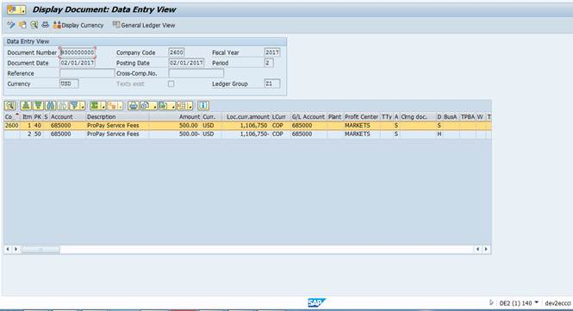

2650

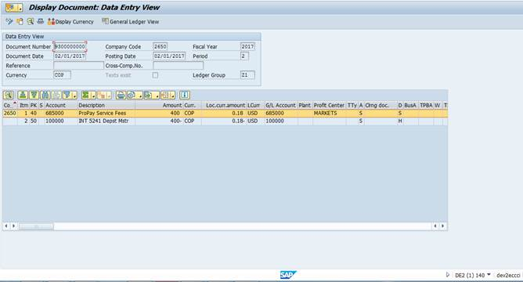

### Screen shot of F-01

